BizTrack360 — Maryam Zahoor Branch Artifacts
Branch: backend | Responsibility: Backend / Application & Business Logic

Purpose of This File
This file contains the SRS artifacts most directly connected to backend processing, task workflow, system events, data flow, notifications, status changes, KPI/report updates and database interaction.

Source
This file is derived from the submitted BizTrack360 Software Requirements Specification (SRS). The artifact descriptions and diagrams below preserve the SRS terminology and content.

Branch Artifact List
- 1. Sequence Diagram
- 2. Level 2 DFD — Task Management
- 3. Activity Diagram — Task Workflow
- 4. State Transition Diagram — System-Level Behavior

1. Sequence Diagram

Purpose / Description
Shows the sequence of interactions among Manager, Employee and System during task handling.

Detailed Artifact Content from the SRS
- Actors: Manager, Employee, System.
- Manager creates a task.
- System stores the task in the database.
- System sends a task-assignment notification to the employee.
- Employee views the task.
- Employee updates task progress.
- A progress update is sent to the system.
- System updates the task status.

Related SRS Requirements
- Users must be authenticated before accessing the system.
- Access must be restricted according to user roles/permissions.
- Task information, progress and status must be stored and tracked.
- System activities must be traceable through activity logs.
- Sensitive data and files must be securely stored.

Original Diagram from SRS (Page 18)
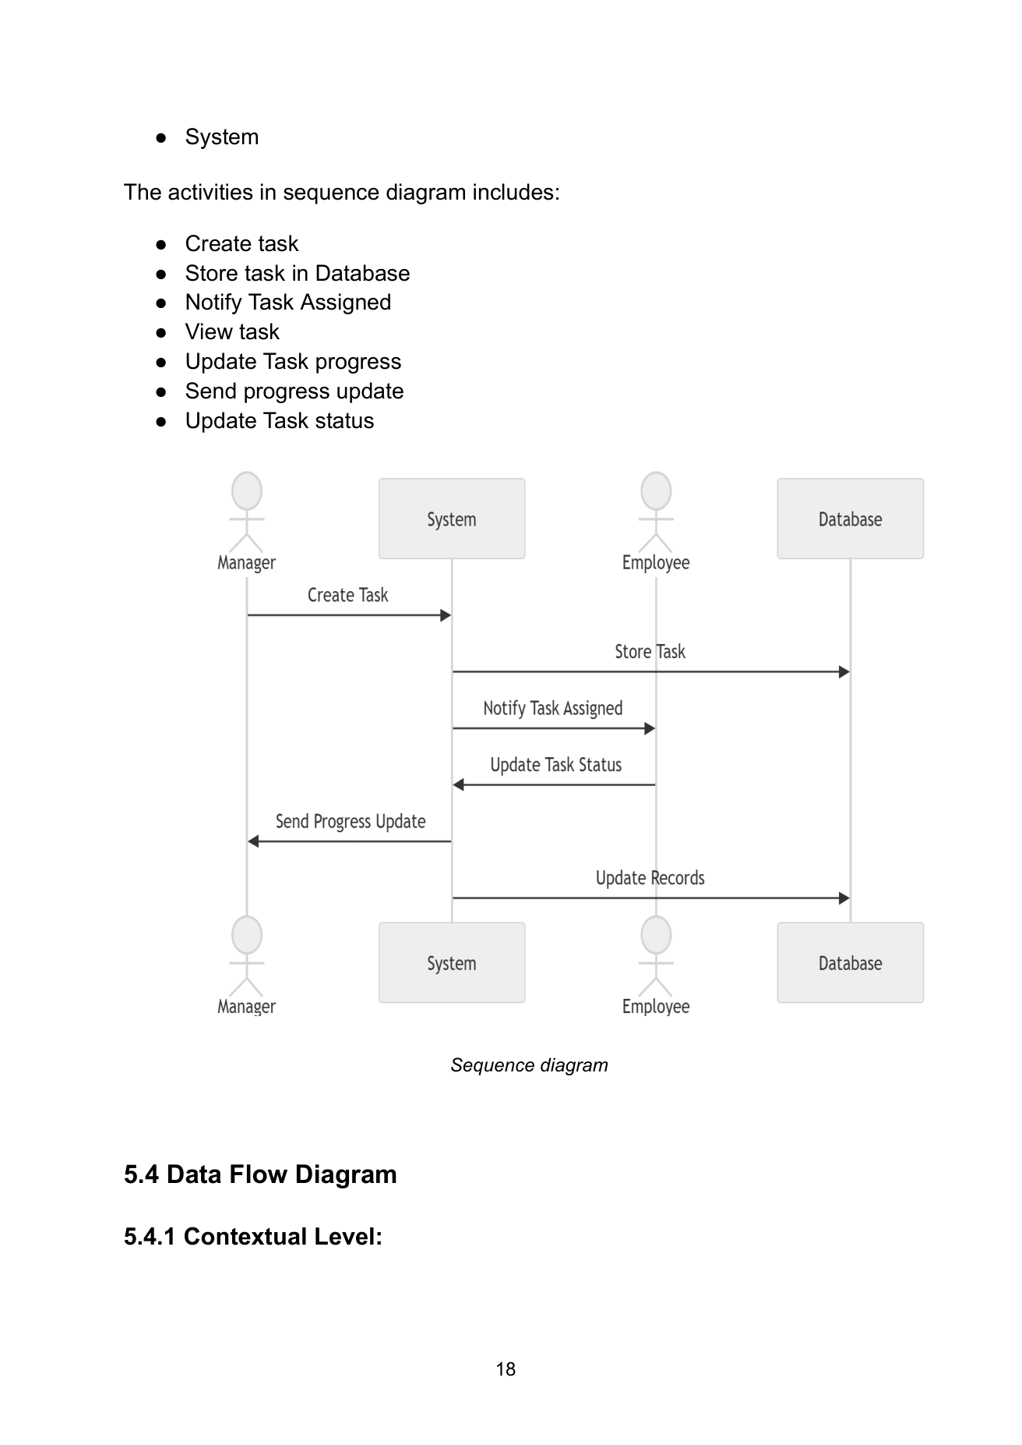

2. Level 2 DFD — Task Management

Purpose / Description
Shows the detailed information flow during task creation, assignment, progress updating and monitoring.

Detailed Artifact Content from the SRS
- Manager creates a task and enters priority, deadline and description.
- System saves task information in the task database.
- After assignment, the notification component informs the employee.
- Employee views assigned tasks and submits progress updates.
- Updated information is stored in the database.
- Manager monitors task progress and reviews completion status.
- The diagram coordinates information flow between managers, employees and the task-management system.

Related SRS Requirements
- Users must be authenticated before accessing the system.
- Access must be restricted according to user roles/permissions.
- Task information, progress and status must be stored and tracked.
- System activities must be traceable through activity logs.
- Sensitive data and files must be securely stored.

Original Diagram from SRS (Page 21)
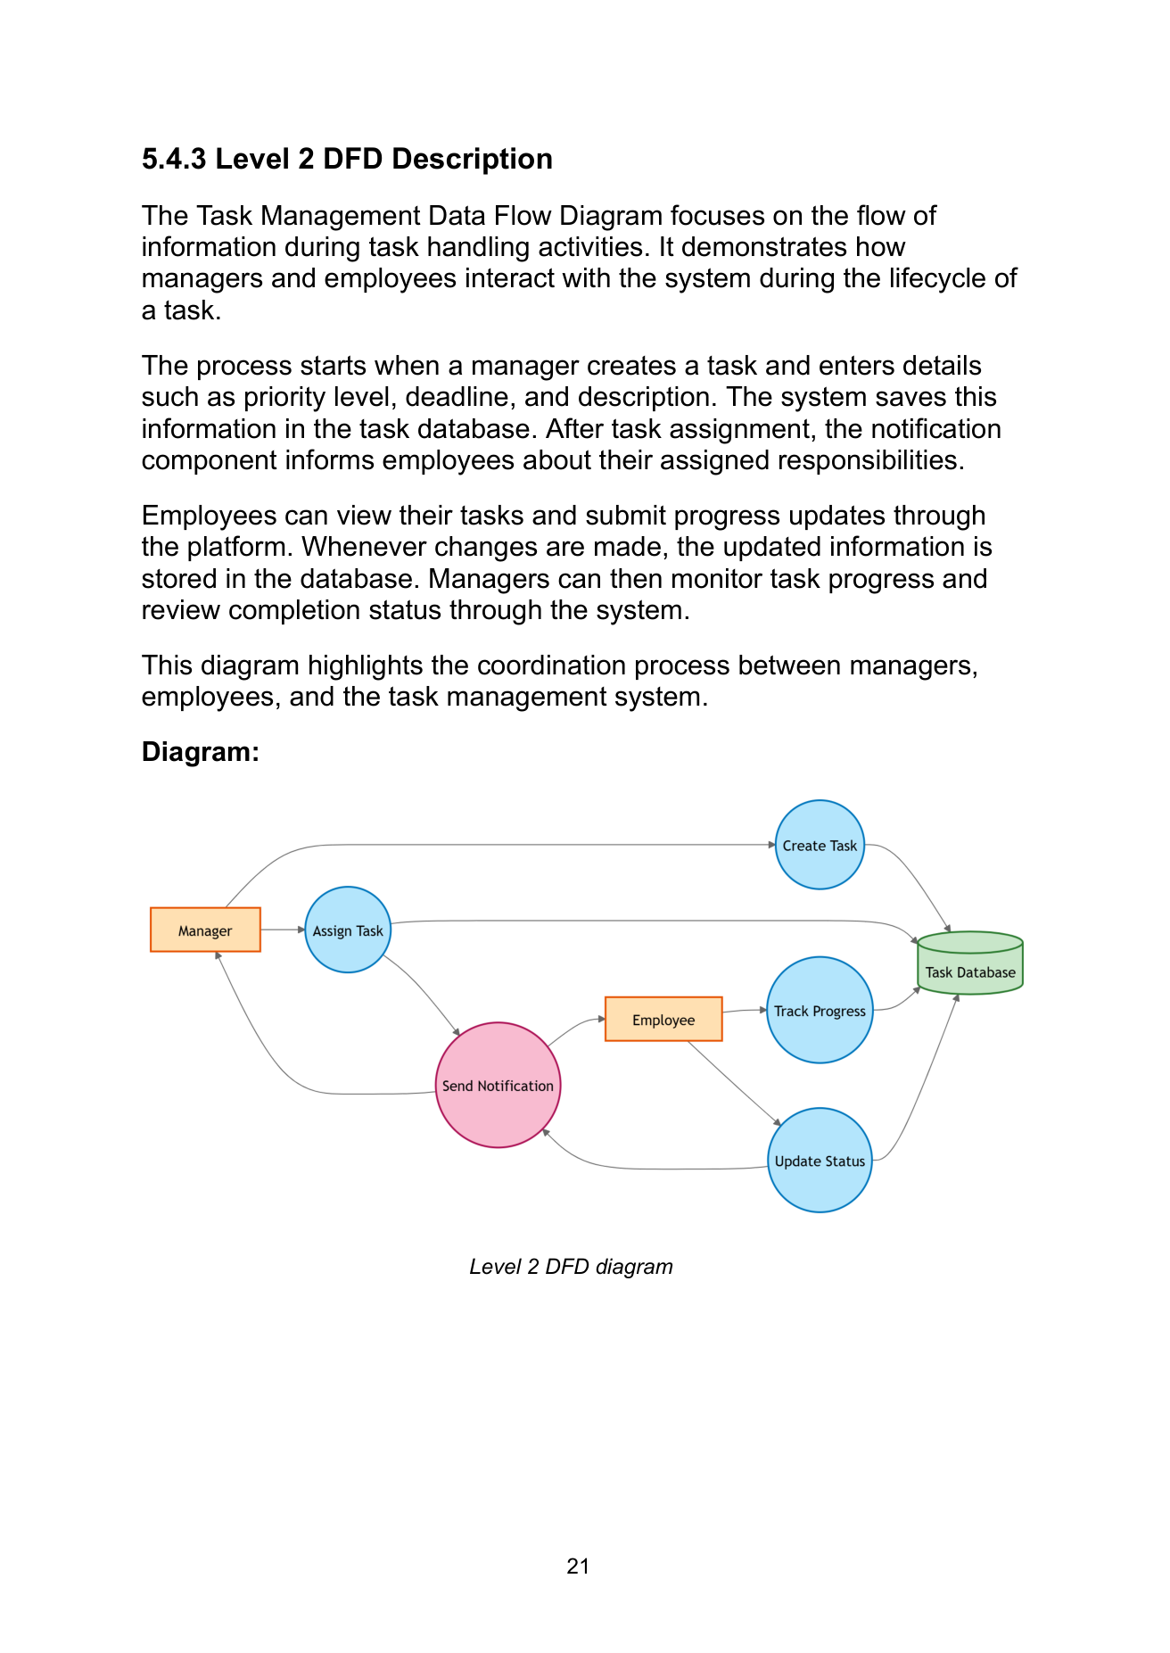

3. Activity Diagram — Task Workflow

Purpose / Description
Represents the complete workflow of task processing from login through completion and reporting.

Detailed Artifact Content from the SRS
- User logs into the system.
- System authenticates the user; failed authentication ends the process.
- Successful authentication takes the user to the dashboard.
- User creates and assigns a task.
- System stores the task and notifies the assigned employee.
- Employee views the task and begins work.
- Progress may be updated repeatedly until the task is completed.
- After completion, KPIs and relevant reports are updated.
- Relevant stakeholders are notified and the workflow ends.

Related SRS Requirements
- Users must be authenticated before accessing the system.
- Access must be restricted according to user roles/permissions.
- Task information, progress and status must be stored and tracked.
- System activities must be traceable through activity logs.
- Sensitive data and files must be securely stored.

Original Diagram from SRS (Page 23)
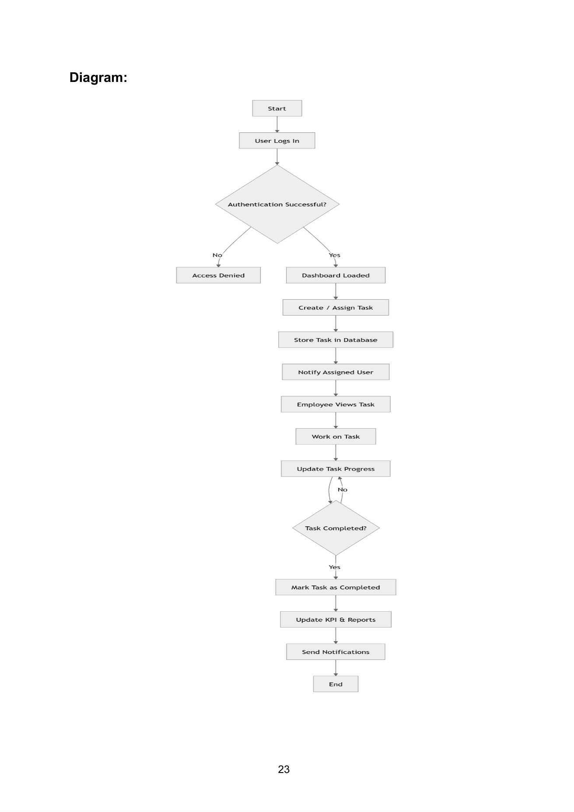

4. State Transition Diagram — System-Level Behavior

Purpose / Description
Explains how automated system events change the task state and trigger database, notification, KPI and reporting actions.

Detailed Artifact Content from the SRS
- A user creates a task.
- The system stores the task in the database.
- The system automatically triggers a notification to the assigned user.
- When the user accesses the task, its state becomes Viewed.
- The task then enters In Progress when work begins.
- Progress changes are continuously recorded.
- When the task is completed, performance metrics/KPIs and relevant reports are updated.
- The completed task is archived for future reference and auditing.

Related SRS Requirements
- Users must be authenticated before accessing the system.
- Access must be restricted according to user roles/permissions.
- Task information, progress and status must be stored and tracked.
- System activities must be traceable through activity logs.
- Sensitive data and files must be securely stored.

Original Diagram from SRS (Page 26)
